Bulk Site Changes

To begin navigate to
Admin > Database utilities and change> 5.sites and click the bulk site changes button
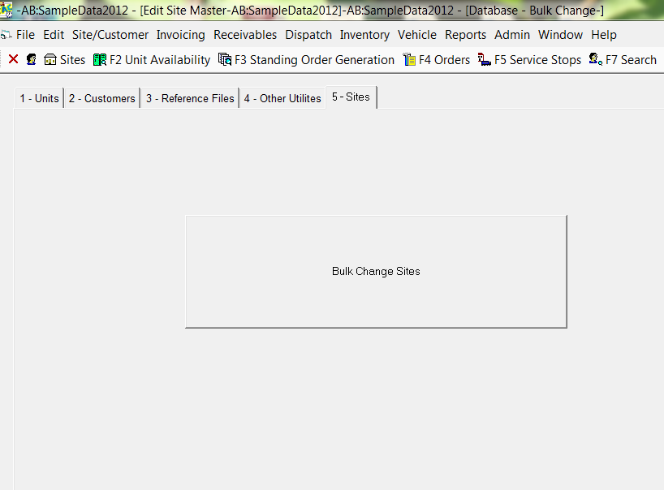
Now select the current criteria for the sites you want to change.
For example city (1-search tab) and tax rate (3-special handling tab) and hit search
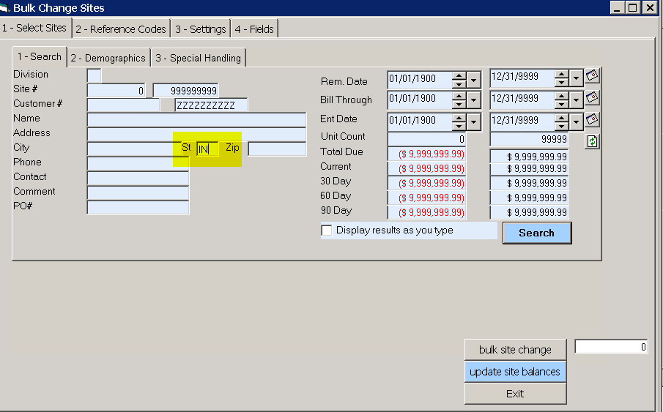
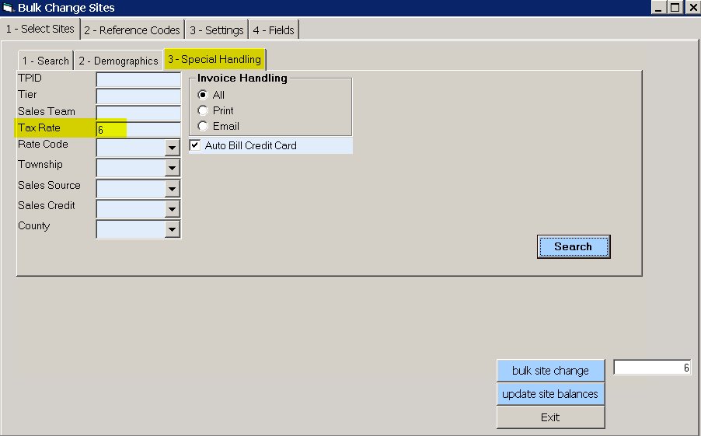
A count will appear near the bulk site change button
Now enter the information you would like to change – example new tax rate would be entered under tab 4-fields sales tax % box
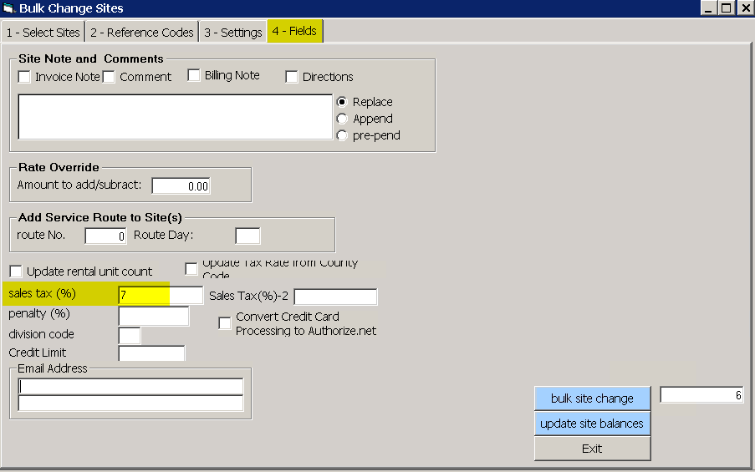
Then click Bulk site change.
Your sites now have the new tax rate

You can always call us to have a backup created prior to the changes just in case the end results are undesirable.

